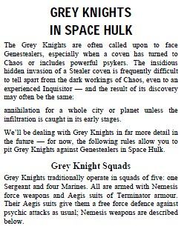

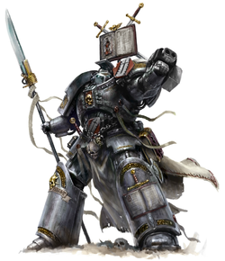

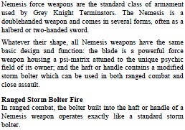

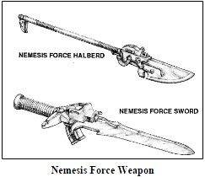

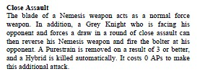

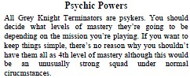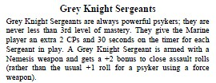

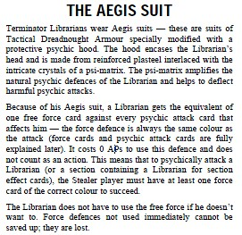

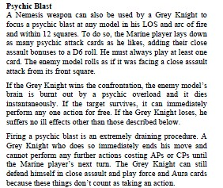

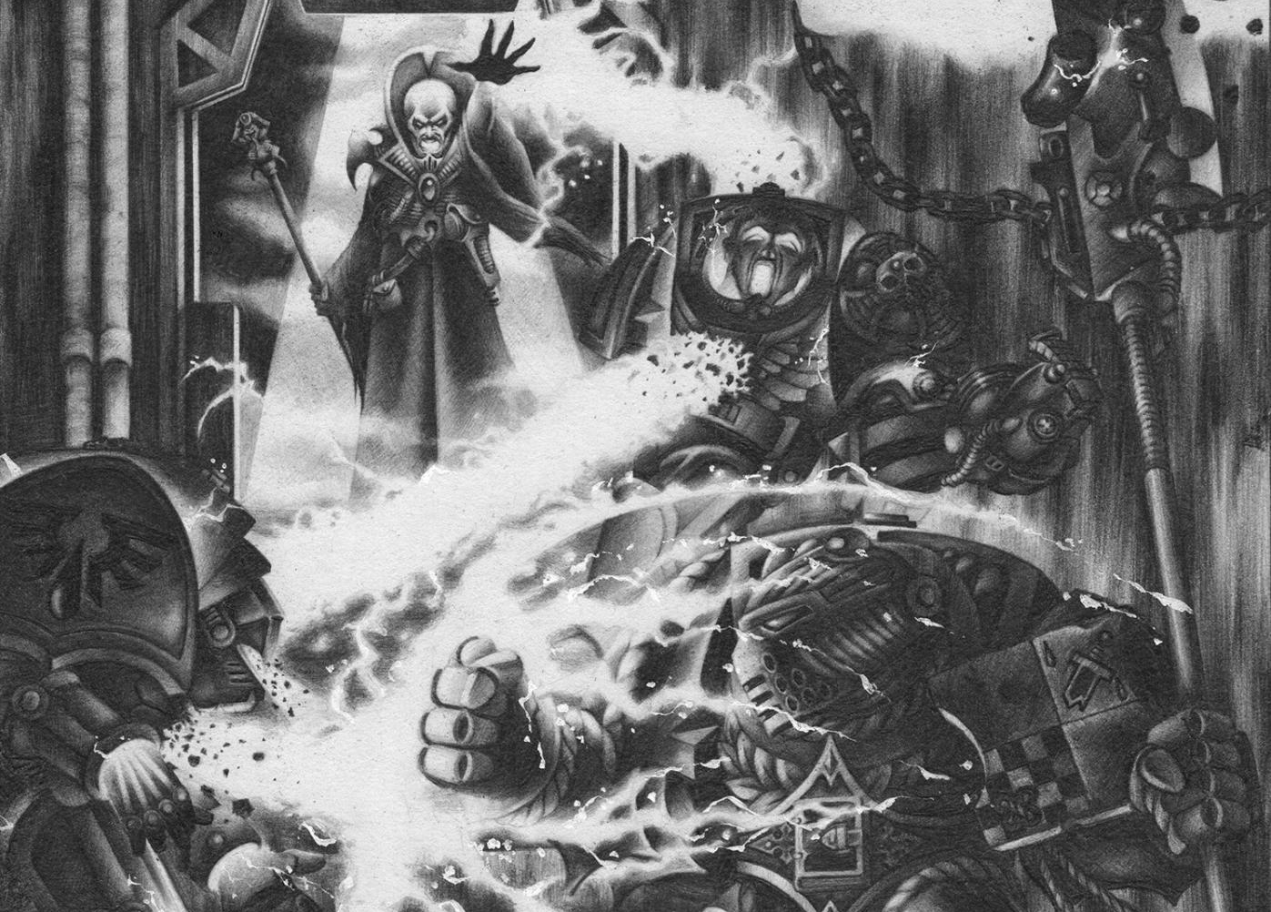

|  |  |  |  |  |
| --- | --- | --- | --- | --- |
| Unit | Action Points | Psi Points | Equipment | Cost |
| Lv.1 Grey Knight | 4 | 10 | -Nemesis Force Weapon (With built in Storm Bolter).  -Aegis Suit. | 15 |
| Lv. 2 Grey Knight | 4 | 20 | -Nemesis Force Weapon (With built in Storm Bolter).  -Aegis Suit. | 20 |
| Lv. 3 Grey Knight | 4 | 30 | -Nemesis Force Weapon (With built in Storm Bolter).  -Aegis Suit. | 25 |
| Lv. 4 Grey Knight | 4 | 40 | -Nemesis Force Weapon (With built in Storm Bolter).  -Aegis Suit. | 30 |
|  |  |  |  |  |
| Lv. 3 Grey Knight Sergeant | 4 | 30 | -Nemesis Force Weapon (With built in Storm Bolter).  -Aegis Suit. | 26 |
| Lv. 4 Grey Knight Sergeant | 4 | 40 | -Nemesis Force Weapon (With built in Storm Bolter).  -Aegis Suit. | 31 |

**Grey Knight Abilities, Weapons and Costs**

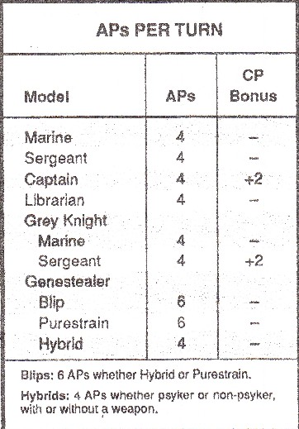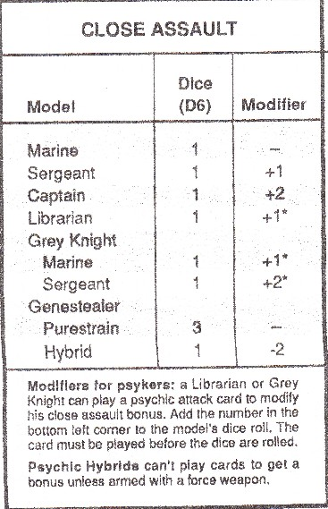

|  |  |  |  |  |  |  |  |  |  |  |  |  |  |  |  |  |  |  |  |
| --- | --- | --- | --- | --- | --- | --- | --- | --- | --- | --- | --- | --- | --- | --- | --- | --- | --- | --- | --- |
| Weapon | Range | Area of Effect | Dice (D6) | Blip | Genestealer | Hybrid | Terminator | Space Marine | Warlock, Avenger, Scorpion, Farseer, Wraithguard, Reaper. Dragon | Guardian, Harlequin, Banshee | Door | Bulk Head | Over Watch | Ammo | Sustain Fire | Fire | Move Forward & Fire | Move Backwards & Fire | Reload |
| PsyCannon | UL | T | 1 | 4 | 4 | 2 | 5 | 3 | 4 | 2 | 2 | - | No | UL | N | 1 | - | - | - |
| Needler/Bolter | UL | T | 2 | 5 | 5 | 3 | 5 | 4 | 5 | 3 | - | - | Yes | UL | Y | 1 | 1 | 2 | - |
| Hand Flamer | 12 | Section | 1 | 4 | 4 | 2 | 4 | 2 | 4 | 2 | - | - | No | 1 shot | N | 1 | - | - | - |
| Melta Gun | 8 | T | 1 | 4 | 4 | 2 | 4 | 3 | 4 | 2 | A | 3 | No | 1 shot | N | 2 | - | - | - |
| Plasma Pistol | 12 | T | 1 | 5 | 5 | 2 | 6 | 4 | 5 | 2 | 5 | - | No | 1 shot | N | 1 | 1 | 2 | - |
| Plasma Grenade | 8 | Section | 1 | 4 | 4 | 2 | 6 | 4 | 4 | 2 | 5 | - | No | 1 shot | N | 1 | 1 | 2 | - |

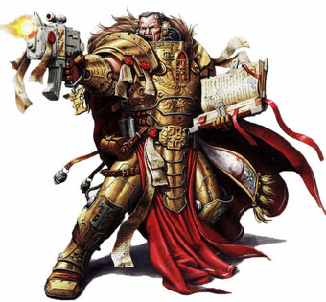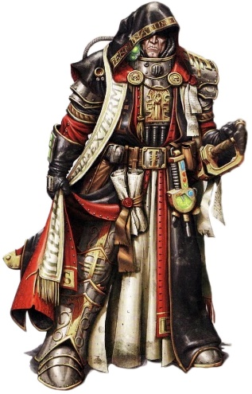

**Inquisitors**

The following is completely fan made, so you can be the Judge as to whether or not you feel it is balanced, I would recommend only using one of these in your Force, this is both fairer and more accurate to lore.

|  |  |
| --- | --- |
| **Imperial Inquisitor:**   * Lv. 4 Psyker, + 2 extra psychic cards. * 4 AP, plus 1D6 -2 (minimum 2) Inquisitor CP per turn. * 2 free Aegis force blocks. * Needler/Bolter Combi-weapon * Psychically Enhanced Power Glove (1D6 +2 CAB) w/ Jokero Digital Weapons **(digital weapons may be used once per game)** may channel psi-points from cards. * Cybernetic Leg (increased mobility Free 90' turns.) * 35 Point cost. | **Ordo Malleus Inquisitor:**   * Lv. 4 Psyker, + 2 extra psychic cards. * 4 AP, plus 1D6 -2 (minimum 2) Inquisitor CP per turn. * 2 free Aegis force blocks. * Psycannon – may channel points from cards. * Force Rod (1D6 + 2 CAB) may channel psi-points from cards * Kinetic Shield (5+ save roll on any normal weapon) * 35 Point cost. |

**Special Rules**  
Inquisitors belong to the Ordo Malleus, and are answerable to no-one but it and the God Emperor. Their life-long struggle against Chaos & other threats to the Imperium often takes them to the very front of battles or - into space hulks. Inquisitors are very resistant to psychic attacks and receive 2 Aegis free force blocks (due to their supreme training, psychic conditioning, and innumerable blessings and holy writs of protection bestowed by the Ordo and God Emperor himself . Many also wear Terminator armour, often enhanced or equipped with experimental force fields or ancient and rare devices. Inquisitors often wield powerful psychically attuned close combat weapons of some kind, and have special ranged weapons. Inquisitors do not count as part of the squad and are not under any other command. Therefore, they may not use the normal squad CP draw, or any CP bonus from lesser ranked models! Instead, they receive 1D6-2 (minimum two) of their own "command" points each turn. This also means the Inquisitor may have up to 8AP per turn to use for himself. Or, these may be (all or only some) given to any other marine, if the Inquisitor chooses to issue orders of his own. **Inquisitor's and normal command points may not be mixed, however - a marine may only get either normal or Inquisitor's CPs.**